Git Setup with Visual Studio 2013

1. Open Visual Studio with Admin Rights
2. Open Team Explorer from View Menu
3. Click on Manage Connections icon

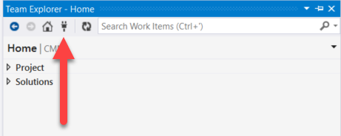

1. Click on **Select Team Projects…** hyperlink

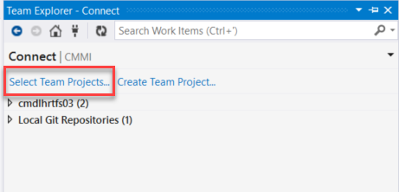

1. From the popup window, click on the **Servers…** button

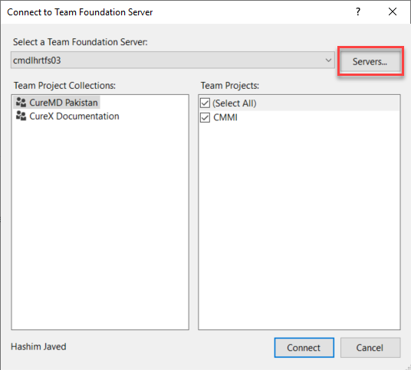

1. From the popup window, click on the **Add…** button

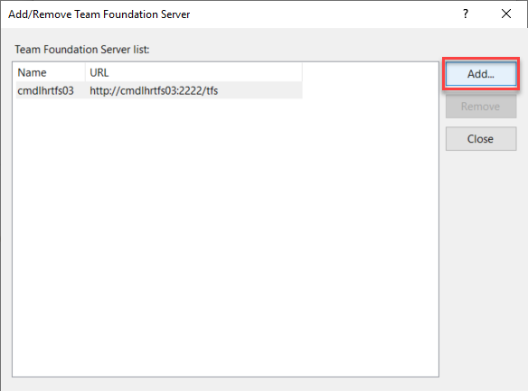

1. Type [**http://cmdlhrdevops/**](http://cmdlhrdevops/) in the **Name** field and click **OK** button

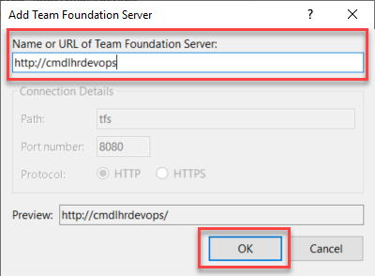

1. The server URL would be added in the list as below. Now close the popup window.

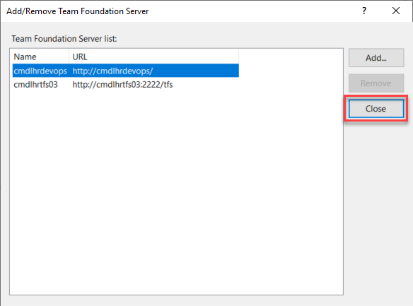

1. In the popup window, make sure that the checkboxes are checked and click on the **Connect**

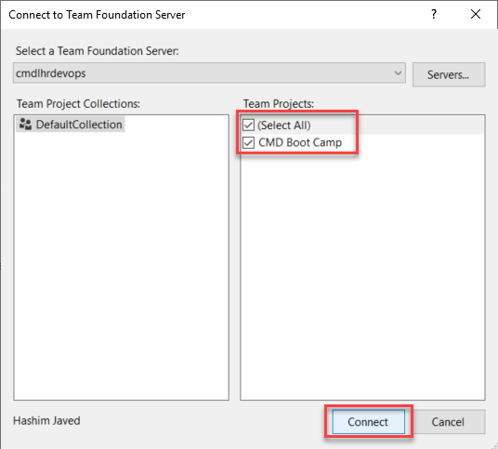

1. From Team Explorer panel, double click on the Repository having your Employee ID and Name

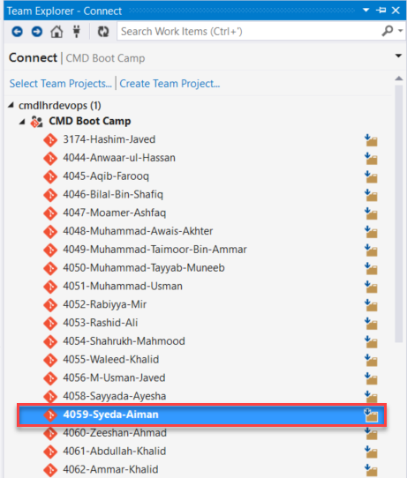

1. Click on the **Clone this repository** hyperlink

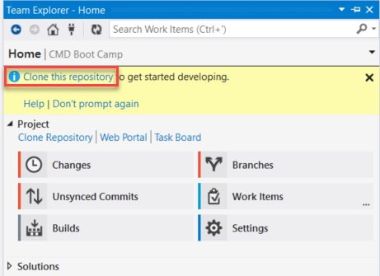

1. Click on the Browse icon

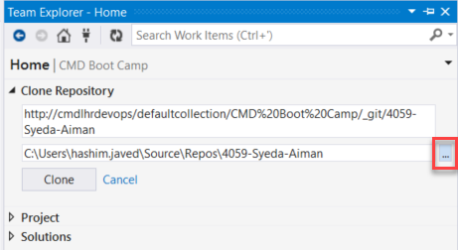

1. Navigate to the ~/Desktop/Repos folder (if not present create one)

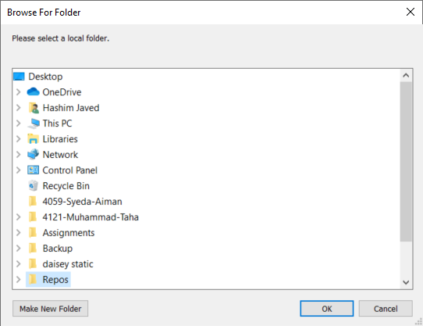

1. Now Click on the **Clone** button

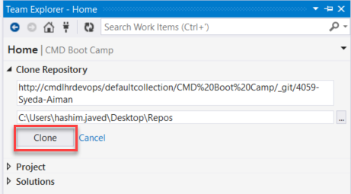

1. The Repository would be successfully cloned

**Branch Creation, First Commit and Push Changes**

1. Open Team Explorer from View Menu
2. Open File Explorer and Navigate to the ~/Desktop/Repos
3. Place the **.gitignore** file inside the folder

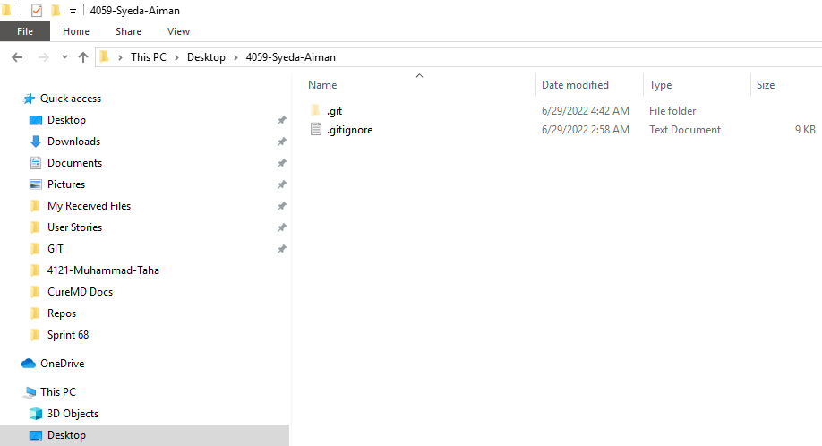

1. Go back to the Visual Studio and Open Team Explorer and then click on C**hanges**

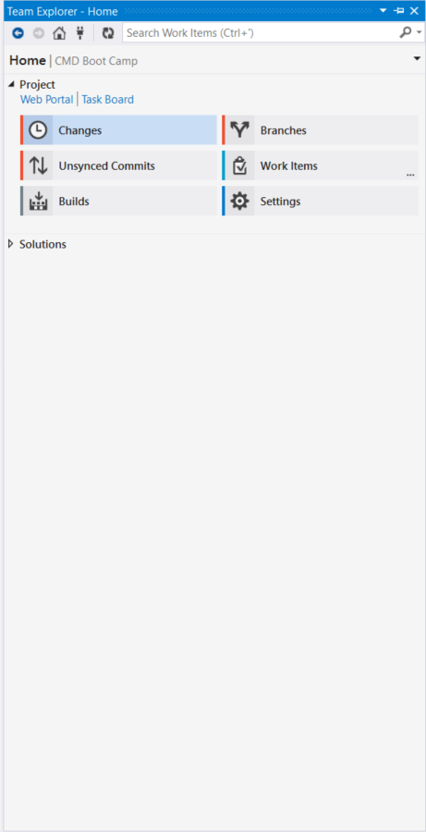

1. In the **Untracked Files** panel, right click on the **.gitignore** file

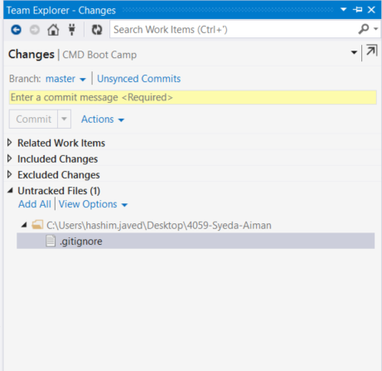

1. Click on the **Add** option

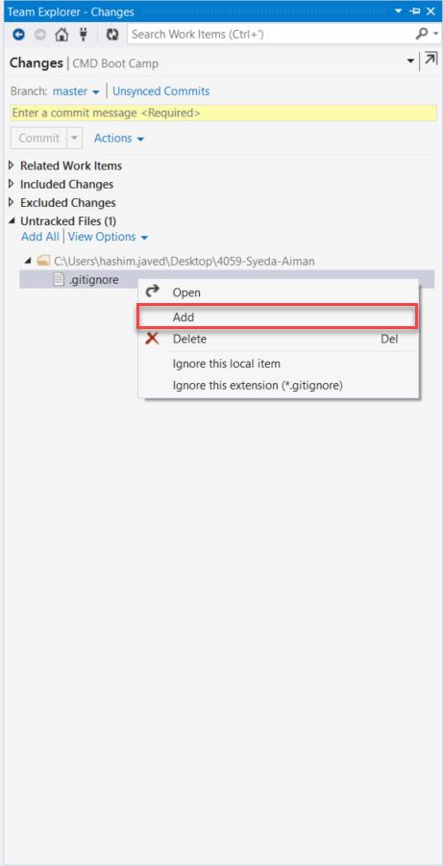

1. The file will move to the **Included Changes** panel

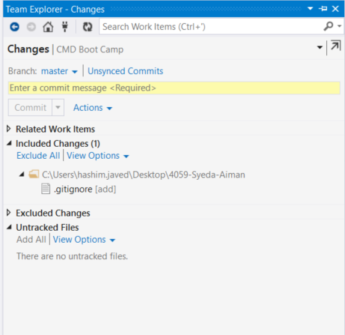

1. Type **First Commit** in the text area and Click on the **Commit Staged**

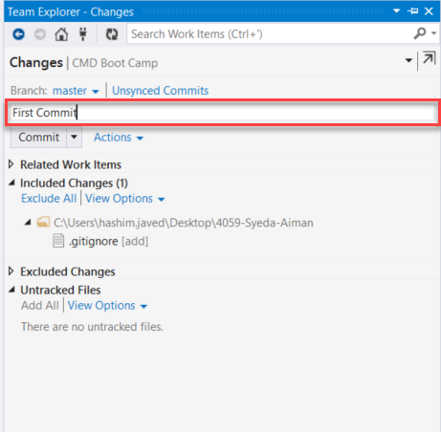

1. Click on the **Commit**

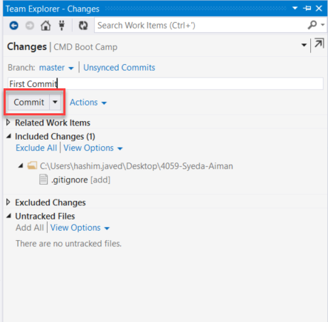

1. You will receive this message which means your commit is successfully created

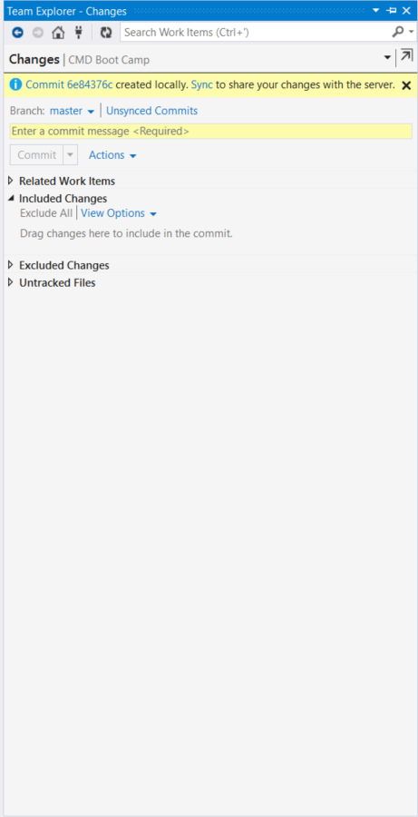

1. Click on the **Home** icon

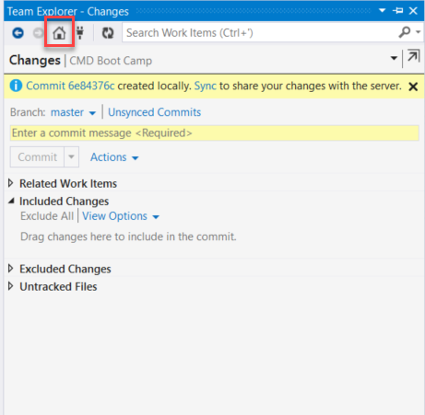

1. Go to the **Unsynced Commits** panel

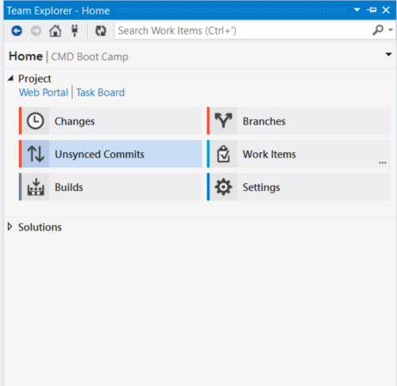

1. You can see your commit in the **Outgoing Commits** section. Now, click the **Push** hyperlink

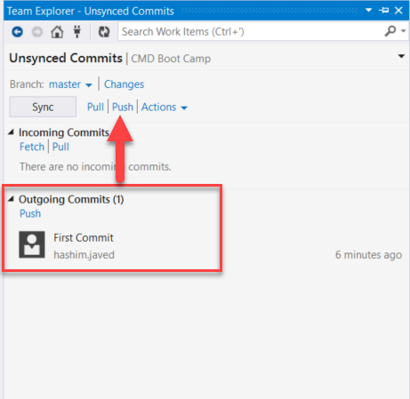

1. System will show that your commit has been successfully pushed

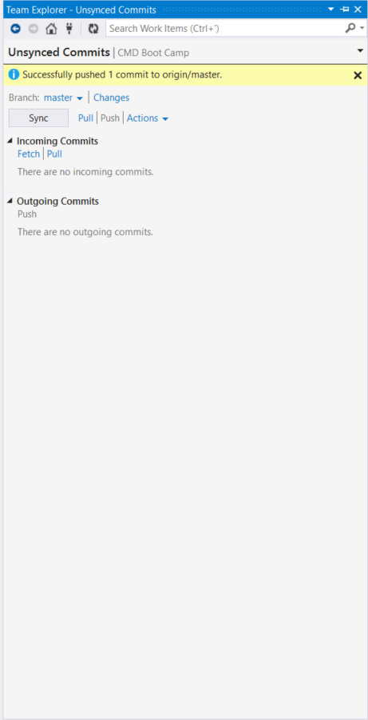

1. Open the DevOps URL:  
   <http://cmdlhrdevops/DefaultCollection/_git/CMD%20Boot%20Camp%202>
2. Find your Repository my searching with your name

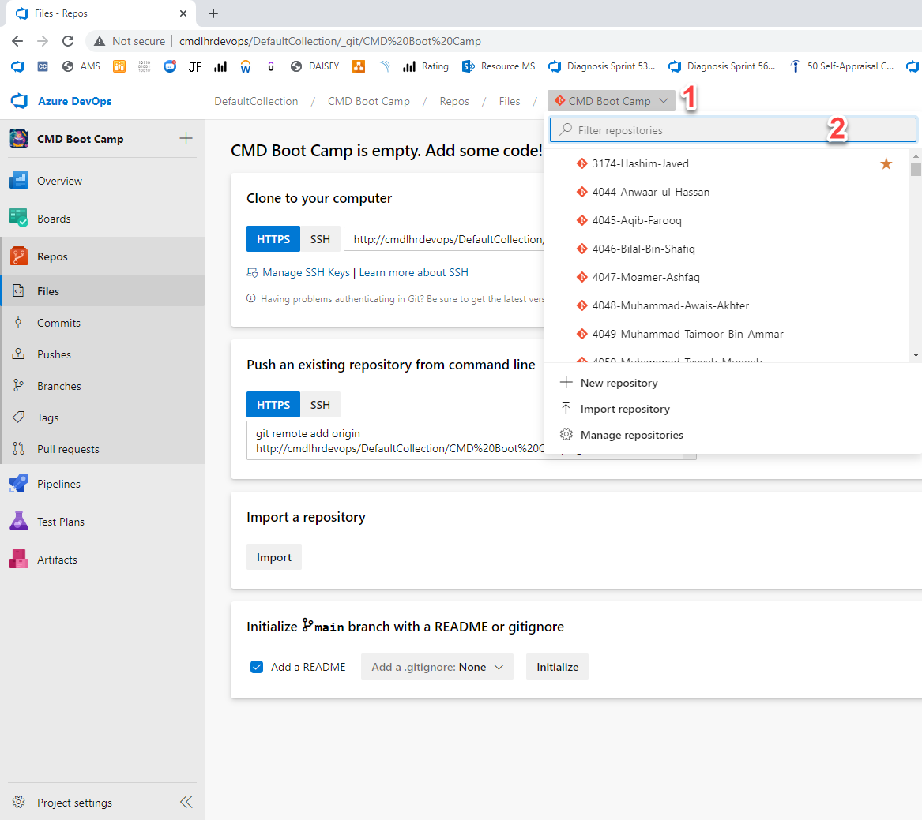

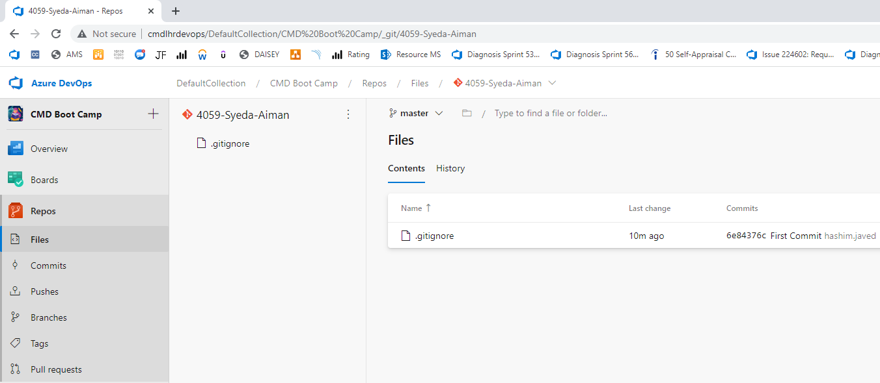

1. In the Visual Studio, go to Team Explorer panel and open **Branches**

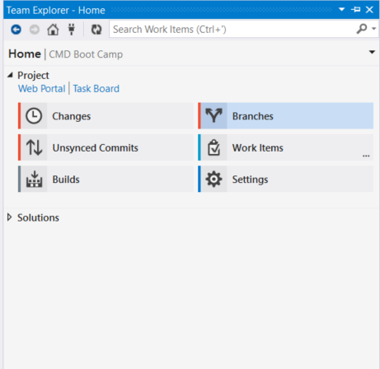

1. Click on the **New Branch** hyperlink

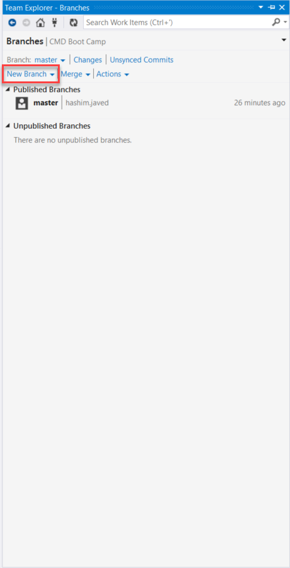

1. Write the name of the branch like **PF-Assignment-01** in the Branch *Name* field and make sure that **master** is select in the field below it then click on **Create Branch**

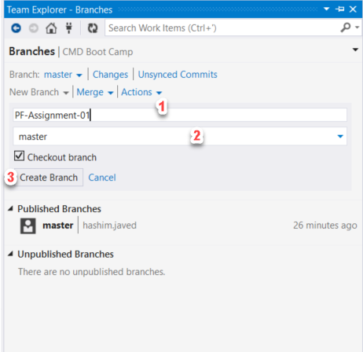

1. New branch will be created under the **Unpublished Branches** tab. Now, right click on it

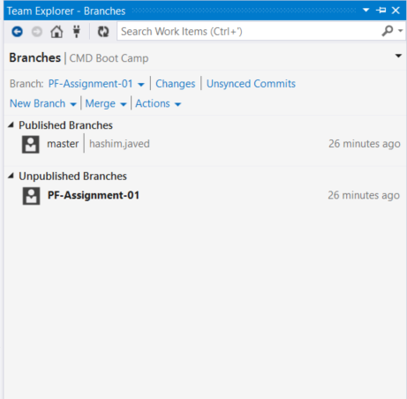

1. Click on the **Publish Branch** option

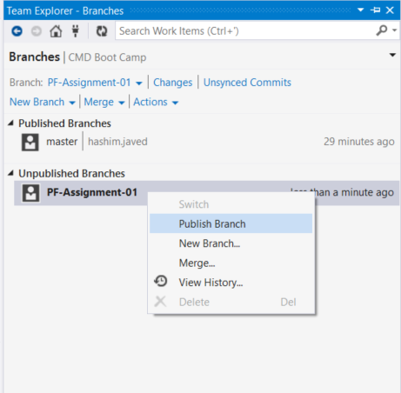

1. The system will show that your branch has been published

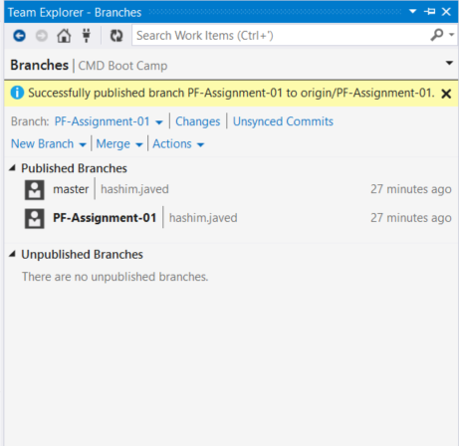

1. Now repeat the above steps to Commit and Push your First Assignment Files in the newly created branch (see below)
2. Place your **\*.cs** or **\*.cpp** files inside the folder ~/Desktop/Repos

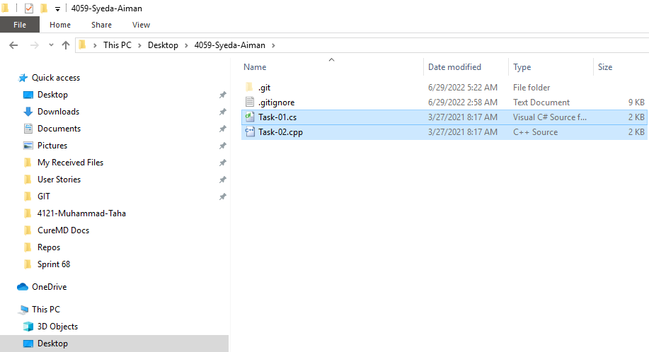

1. Go back to the Visual Studio and Open Team Explorer
2. Repeat from Step #4

**Commit | Push | Repeat**